Name: Hafiz M. Muneeb Akbar
Roll No: SU92-BSAIM-F24-048
Subject: Programming for Artificial Intelligence (LAB)

Lab Task 9
Text Classification — Spam Detection
Code Documentation & Concept Reference

Project Overview
This notebook implements a Text Classification pipeline to detect whether a given message is Spam or Ham (not spam). It uses the Bag of Words model via CountVectorizer to convert text into numerical features, and a Multinomial Naive Bayes classifier from Scikit-learn to learn patterns and make predictions. The pipeline covers dataset preparation, vectorization, model training, evaluation, and an interactive testing loop.

1. Background — Key NLP Concepts
Before diving into the code, here are the key NLP concepts this task is built on:

Concept | Explanation
Natural Language Processing (NLP) | A branch of AI that enables computers to understand and process human language.
Text Classification | The task of assigning a predefined label (e.g., Spam or Ham) to a piece of text.
Bag of Words (BoW) | A model that represents text as a vector of word counts, ignoring word order and grammar.
Stopwords | Common words like 'the', 'is', 'in' that carry little meaning and are removed before processing.
Tokenization | Breaking a sentence into individual words or tokens so they can be counted and analyzed.
Naive Bayes | A probabilistic classifier that uses word frequencies to estimate the likelihood a message belongs to each class.

2. Importing Libraries
The notebook imports the following modules from Scikit-learn to build the pipeline:

Import | Purpose
CountVectorizer | Converts text messages into a matrix of word frequency counts (Bag of Words representation).
MultinomialNB | Multinomial Naive Bayes classifier — works well with discrete frequency data like word counts.
train_test_split | Splits the dataset into training and testing subsets for unbiased model evaluation.
accuracy_score | Measures the fraction of predictions that match the true labels.
classification_report | Prints per-class precision, recall, F1-score, and support for a full evaluation summary.

3. Preparing the Dataset
A manually created dataset of 20 labeled messages is used — 10 spam and 10 ham. Each message is paired with a label: 1 for spam and 0 for ham. This balanced dataset ensures the model learns equally from both classes.

Variable | Description
messages | A Python list of 20 text strings — real-world style spam and ham messages.
labels | A list of 20 integers (1 = spam, 0 = ham) corresponding to each message.
labels.count(1) | Returns the count of spam messages in the dataset (10).
labels.count(0) | Returns the count of ham messages in the dataset (10).

4. Vectorization — Converting Text to Numbers
Machine learning models cannot work with raw text. CountVectorizer converts each message into a numeric vector where each element represents how many times a specific word appeared in that message. The stop_words='english' parameter filters out common English words like 'the', 'is', and 'a' that do not help with classification.

Function / Parameter | Explanation
train_test_split(messages, labels, test_size=0.2) | Splits data into 80% training and 20% testing. random_state=42 makes the split reproducible.
CountVectorizer(stop_words='english') | Creates the vectorizer object. Setting stop_words='english' removes common words automatically.
vectorizer.fit_transform(X_train) | Learns the vocabulary from training messages and converts them into a word-count matrix.
vectorizer.transform(X_test) | Converts test messages using the same vocabulary learned from training — no re-learning.
vectorizer.vocabulary_ | A dictionary mapping each word to its column index in the feature matrix. Size = total unique words.

Why fit on training data only?
The vectorizer is fit only on training data using fit_transform(), then applied to test data using transform(). This simulates real-world conditions where the model must handle messages it has never seen. Fitting on the full dataset before splitting would cause data leakage — the model would indirectly 'see' test words during training.

5. Training the Model — Multinomial Naive Bayes
Multinomial Naive Bayes (MultinomialNB) is a fast and effective algorithm for text classification. It works by calculating the probability that a message belongs to each class based on the frequency of words in it. It assumes each word contributes independently to the classification — which is the 'naive' assumption.

Function / Call | Explanation
MultinomialNB() | Creates the Naive Bayes classifier object with default settings.
model.fit(X_train_vec, y_train) | Trains the model by learning which words are more common in spam vs ham messages.
model.predict(X_test_vec) | Predicts the label (0 or 1) for each test message based on learned word probabilities.
accuracy_score(y_test, y_pred) | Compares predictions to true labels and returns the fraction that are correct (0.0 to 1.0).
classification_report(..., target_names=['Ham','Spam']) | Prints precision, recall, and F1-score for both Ham and Spam classes.

Evaluation Metrics Explained

Metric | What It Means
Accuracy | Overall percentage of correctly classified messages.
Precision | Of all messages predicted as Spam, how many were actually Spam?
Recall | Of all actual Spam messages, how many did the model correctly catch?
F1-Score | The harmonic mean of Precision and Recall — a balanced single metric.
Support | The number of actual instances of that class in the test set.

6. Testing on New Messages
Five unseen messages are passed to the trained model to verify it generalizes correctly. The same vectorizer.transform() is used (not fit_transform) so the vocabulary stays consistent. Results are printed alongside the original messages for easy comparison.

Step | Explanation
test_messages = [...] | A list of 5 new messages the model has never seen during training.
vectorizer.transform(test_messages) | Converts the new messages using the already-learned vocabulary.
model.predict(test_vec) | Returns a prediction (0 or 1) for each of the 5 test messages.
zip(test_messages, predictions) | Pairs each message with its corresponding prediction for clean output printing.
'SPAM' if pred == 1 else 'HAM' | Converts the numeric label back into a readable string for display.

7. Interactive Spam Detector
The final section provides a live interactive loop where the user can type any message and the model instantly classifies it as SPAM or HAM. It also displays the confidence percentage — how sure the model is about its prediction. The loop runs until the user types 'exit'.

Function / Line | Explanation
input('Enter message: ') | Takes a message from the user as a string input during runtime.
vectorizer.transform([user_input]) | Wraps the single input in a list and converts it to a feature vector.
model.predict(input_vec)[0] | Returns the predicted label (0 or 1) for the user's message. [0] extracts the single value.
model.predict_proba(input_vec)[0] | Returns the probability scores for both classes [ham_prob, spam_prob].
max(probability) * 100 | Gets the higher probability and converts to a percentage — this is the confidence score.
sentence.lower() == 'exit' | Checks if the user typed 'exit' to stop the loop gracefully.

8. Key Concepts Summary

Concept | What It Is | Where It's Used
Bag of Words | Text representation as word frequency counts | CountVectorizer
Stopword Removal | Filtering out meaningless common words | CountVectorizer(stop_words='english')
Train/Test Split | Dividing data to evaluate model on unseen samples | train_test_split()
Naive Bayes | Probabilistic classifier based on word frequencies | MultinomialNB
fit_transform vs transform | fit_transform on train only; transform on test to avoid leakage | Vectorizer calls
predict_proba | Returns class probabilities instead of just labels | Confidence display in interactive mode

Output Screenshot

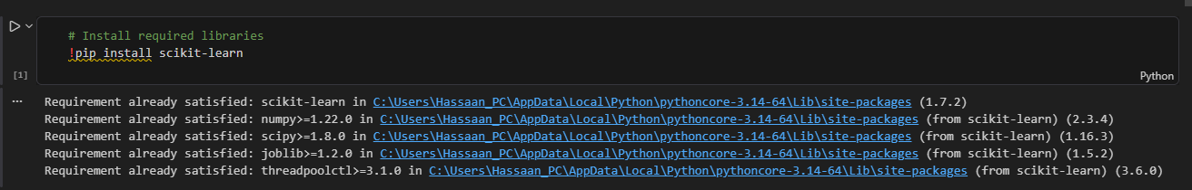
Figure 1: Library Installation

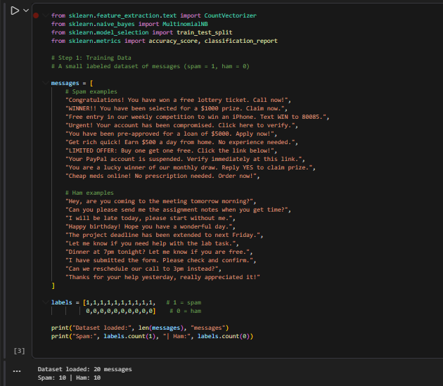
Figure 2:Dataset Loading

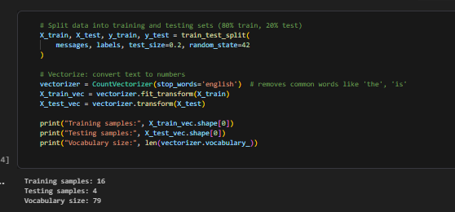
Figure 3: Vectorization and Train/Test Split
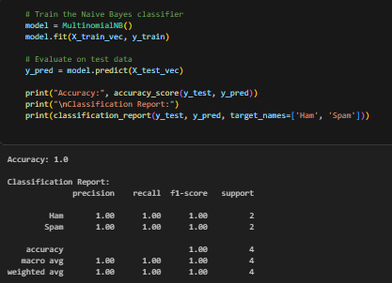
Figure 4: Model Training and Evaluation Report

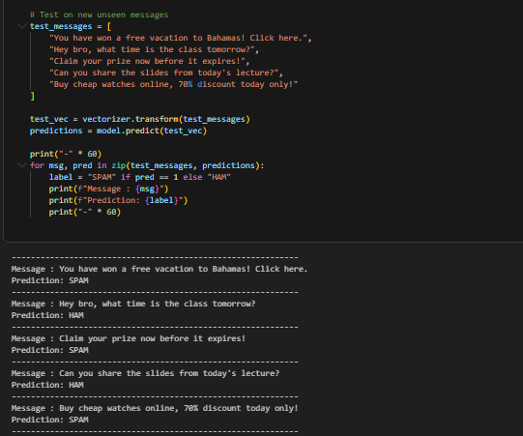
Figure 5: Batch Testing on New Messages

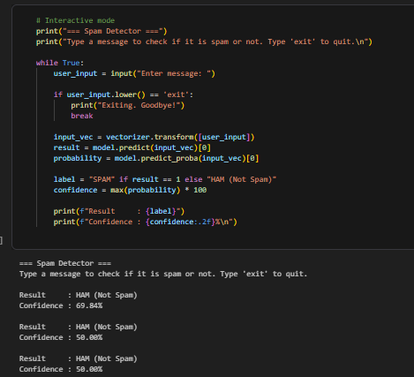
Figure 6: Interactive Spam Detector in Action

